Microsoft SQL Server Management Studio

Like a Visual Studio for Databases  
Similar to Visual Studio. Recommended as better for database work.  
Download and Install from:  
<https://docs.microsoft.com/en-us/sql/ssms/download-sql-server-management-studio-ssms>

Current version is 17.5 as at writing this 27 Feb 2018

-----------------------------------

Start Microsoft SQL Server Management Studio

Our Server is:

**citizen.manukautech.info,6307**

No spaces and a comma, NOT a dot, before the 6307 which is a non-standard port number.  
Use the account details given to you by your lecturer to get started with Username and Password

You can check (tick) the box "Remember Password" if you are logged in to a secure environment eg your own laptop with an account that only you would ever use and no-one else has admin rights on your machine.

Do NOT connect first up – you need to configure some "Options"  
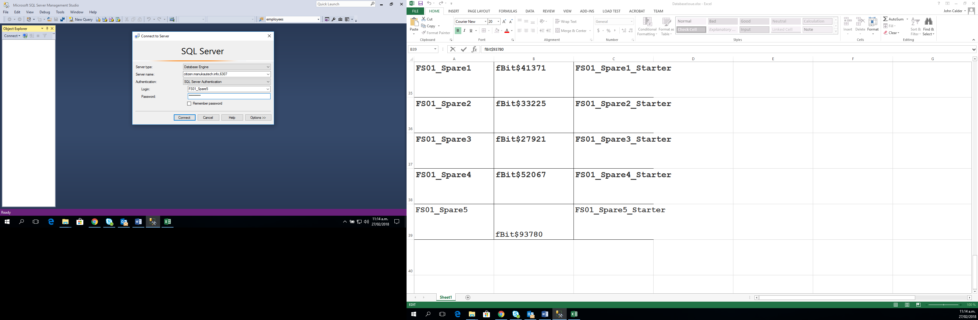

Options – make sure 2 x checkboxes are checked (ticked)  
"Encrypt connection" and "Trust server certificate"  
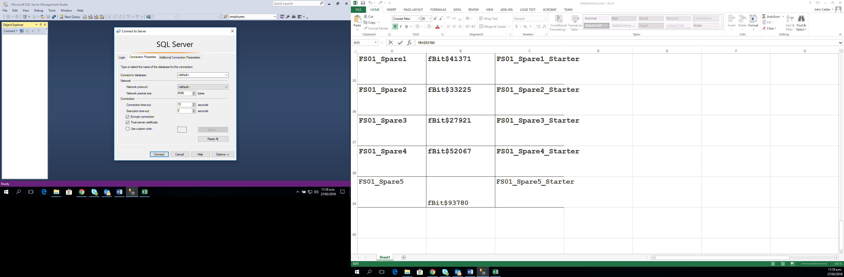

Then "Connect"

**Your account includes a starter database.**

In this example, a student with name "Spare5" has:  
Username: FS01_Spare5  
Starter Database: FS01_Spare5_Starter

Students can see other Student's databases in the left explorer pane.  
However students can only get access into their own databases, and that includes new databases that students create.

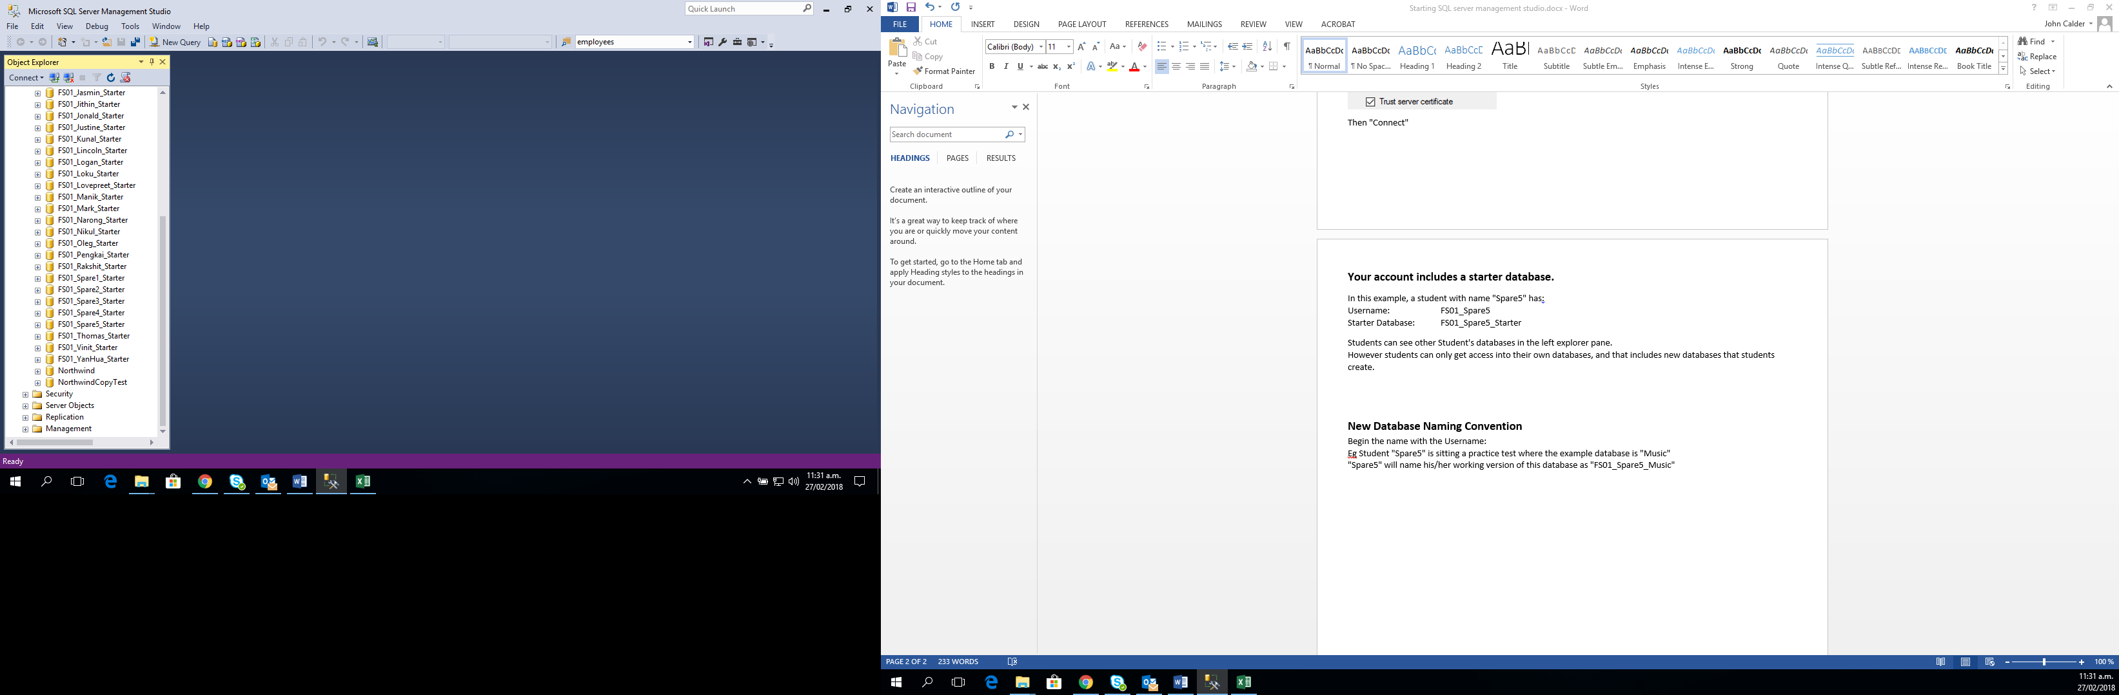  


**New Database Naming Convention**  
Begin the name with the Username:  
Eg Student "Spare5" is sitting a practice test where the example database is "Music"  
"Spare5" will name his/her working version of this database as "FS01_Spare5_Music"

Expand a Database to work on it.

Right-click on the Database parent node for options, most of which are not useful until the database has data in it.

To create a new table:

Right-click on child node "Table" then Select "Table …"